The Trail
One potential game that you could create is something along the lines of the snake game on the Nokia phones…

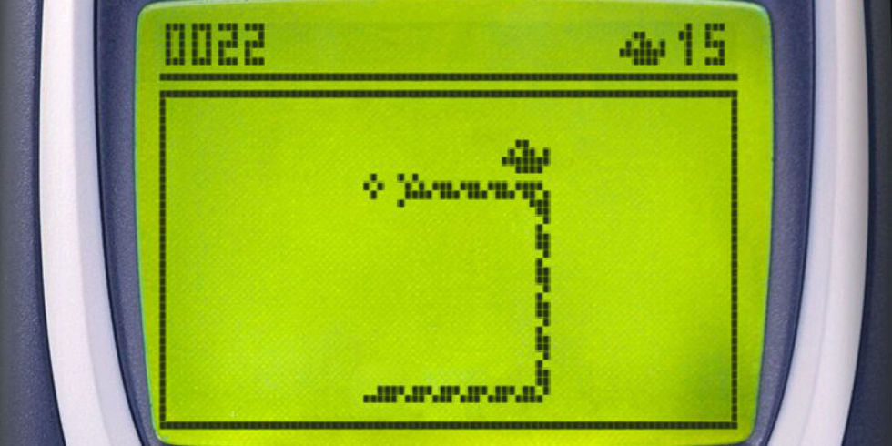
The graphics are pretty simple, yet it is likely one of the most famous games ever especially on a mobile platform.
In building this game the question arises “how does the tail work?”
Like most things you see in game it is something of an optical illusion and it is worth understanding how the tail really works before looking at some code examples.
We shall use the example on the module web site called The Tail, which looks allows you to do this sort of thing…
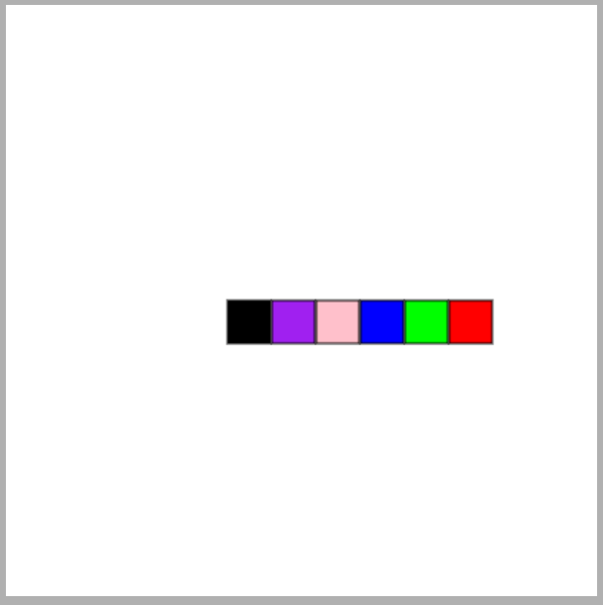
The segments of the trail have been colour coded to make it clearer what is happening.
Let’s go through step by step.
In the code there are two sprites, head.js and segment.js
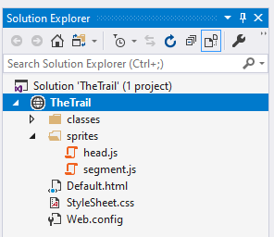
When the game starts, we see only the head sprite…
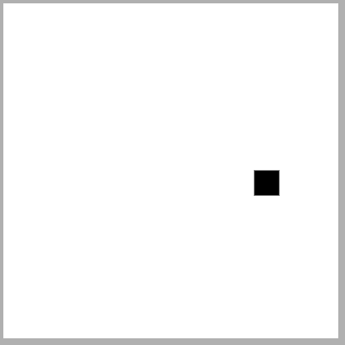
In addition to the head sprite there is a collection of five segment sprites.
At start-up the segments have the same x and y of the head so they are hidden by the head sprite sitting on top.
Each segment is colour coded…
- Purple
- Pink
- Blue
- Green
- Red
First the player moves the head sprite say to the left…

This uses the head sprite’s left method which looks like this…
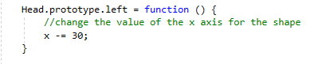
This method is triggered by the event handler…
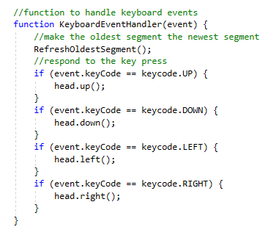
Notice at the top of the event handler there is a call to the function RefreshOldestSegment in Default.html.
What this function does is that it the “oldest” segment in the tail and makes it the “youngest”.
Each segment when it is positioned on the canvas is given a life value of 30…
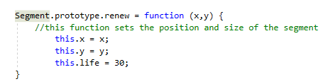
The functions that drive this process are here…
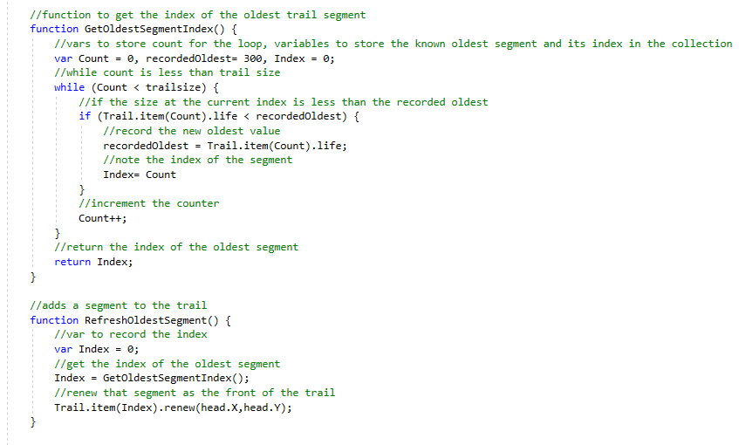
The first function identifies the oldest segment in the trail and returns the index of that segment in the collection…
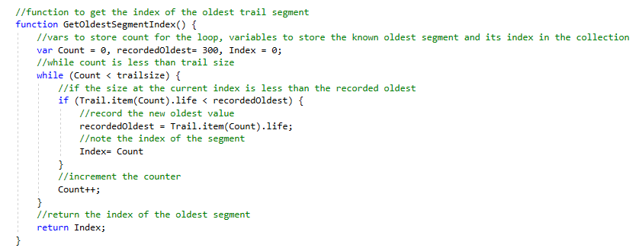
The second function uses this function to identify which segment is the oldest and make it the newest.
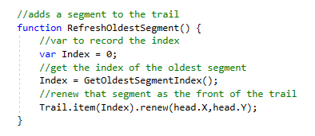
The last thing this function does is give that segment the same coordinates of the head sprite making it the front of the trail.
Since this is the first time a segment has been initiated all of the segments will be the oldest segments so the purple segment index zero will now become the “youngest” segment.
The purple segment is placed at the coordinates of the head. When the head is moved to the next position the purple segment becomes visible.
The user now presses the left arrow key again…

Note that the purple segment stays where it is, none of the tail segments are moving in this process.
The head moves one square to the left. The purple segment stays where it is but its “life” in now reduced to make it a little “older”.
This function in segment.js does this…
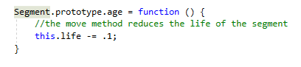
The green segment is now the youngest segment, followed by the purple segment. All the other segments are hidden by the purple segment and are all the oldest.
Note that the segment doesn’t ever move it just gets “older” with less “life” leaving a footprint of where the head once was.
The user presses the left arrow again and the blue segment is made the youngest segment, placed in the trail of the head…

As before the green and purple segments don’t move, they just get a bit “older”.
This process repeats until all five segments have been initialised which gives us the following…

In this version of the game the trail length is set to a maximum of 5 segments.
The red segment is now the oldest segment and it has so far been hidden by the other segments sitting on top of it.
The user presses the left arrow again…
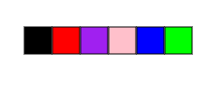
The red segment previously the oldest segment is now the newest segment placed in the trail of the head sprite. Again, note that all of the other segments don’t in fact move, they just get older.
The user presses the left arrow again…

This time the green segment is made the youngest segment.
The illusion is created that the tail is moving, when it is not.
All that is happening is that the oldest end of the tail is renewed to be the newest end of the tail placed at the last position of the head sprite.

